**MuleSoft Object Store**

* Mule component ,allow key -value store.

**->storing synchronization information  (WaterMark)**

**-> Store temporal information , (access key)**

**->storing user information**

* Mule component uses Object Store

**->cache module**

**->OAuth module**

* Object Store Limitation

**->Not a universal Solution for data Storage , not database**

**Object Store Operations**

**->Store**

**->Retrieve all keys**

**->Retrieve all**

**->Remove**

**->Retrieve**

**->Contains**

**->Clear**

* **Store**

Stroe operatoruse to store the data in the memory

->in Store operation in general settings we have four function

1) Key:- we can pass this as Dynamic or hard code key

2) Value:- this the value we store in the object Store

3) Fail if Present:-

If the value is False,the data will overwrite.

If the value is True, it will not overwrite and it give the message of

(object Storealready contains an object for key )

4) Fail on null value:- when we are passing a null value it going to fail when the value was true

If the value was false . it pass the null record

* Remove

->remove operation remove the specific key in the object store

Example :- if the object store contrails (key1,key2,key3)

if we want to remove the key1 , in this case we can use the remove operator.

* **Retrieve**

-> Retrieve operation was used to retrieve the stored data in the object Store

->in Retrieve operation in general settings we have two function

Key:- in the argument we pass the required key name

Default value :-if the key was not available in the object store , it pass the Default value message

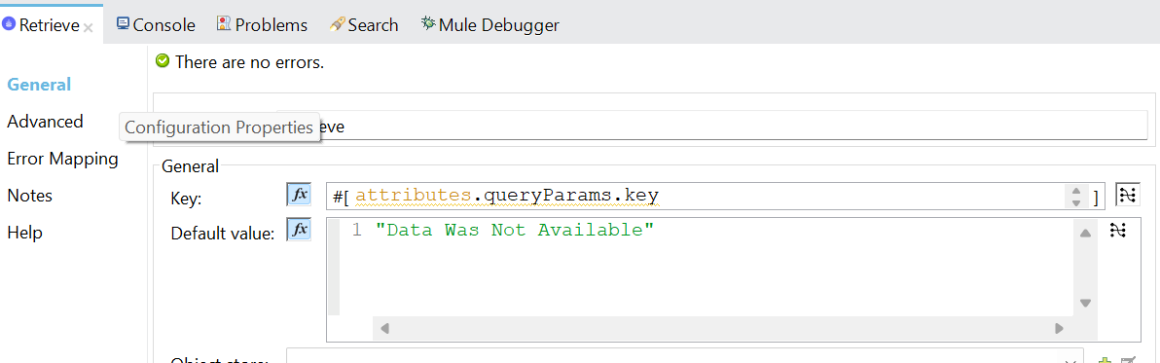

* **Contains**

->In Contains was a bullion response it gives the true and false response

If the key was present I the object store , it the value as true.

If the key was not present , it the value as false.

->In contains operation we need to pass the key argument

* **Clear**

->In clear operation it will clear all the Stored data in the object Store

-> for this operation we no need to pass any Argument

* **Retrieve all.**

->In Retrieve all operation it will retrieve all the Stored data in the object Store

-> for this operation we no need to pass any Argument

* **Retrieve allKeys.**

->In Retrieve allkeys operation it will retrieve all keys in the Stored data in the object Store

-> for this operation we no need to pass any Argument

* **Memory Store in Object Store in local**

**->Anypoint Platform ->plugins -> mule server (org.mule.tooling.server.4.4.X) ->**

**mule -> .mule -> Name of your project -> object Store**

**->In this above Location we can see all the Storage data in local machine**

**Mule Soft object Store configuration setting**

* **Setting Parameters**
* Entry TTL:- how much time key is existed , that we can mention here.

If we are not providingEntry TTL value , then it was not going to expire.

* Entry TTL unit :- time range (sec, min ,HR)
* Expiration interval :-it is a thread running based on the time.

It is going the delete the Expiry Entry TTL

And it also checks the max Entries. And delete the old keys.

* Expiration interval unit :-time range (sec, min ,HR )
* Persistent :- if we unable the persistent , it will store all the keys in the mule file

system(if the mule server was down we are not to loss data will data

it was stored in the inter file memory)

if we are not unable the persistent , it will not store the keys in the mule.

file system (if the mule server is going, we can’t retrieve the data)

* Max Entries :-exceeding entries are removed when expiration thread runs if value was not defined no size boundaries.

**Some Examples for object Store configuration setting**

Case 1:-

As per the below example entry TTL was 10 S and Expiration interval was 12 S

-> After the entry TTL expire also value was present for next 2min

->Expiration interval always less than entry TTL.so it will not available after expiry

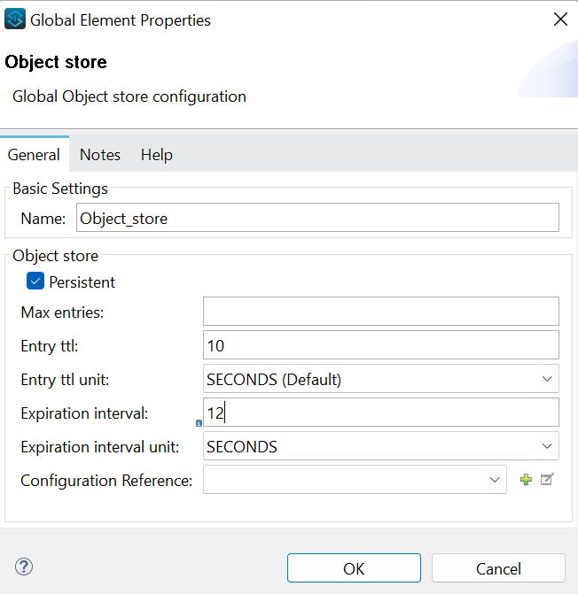

Case2:-

->If we give Entry TTL was 0 (or) -1 and Expiration Interval was present or not present

There was no expiration for the data

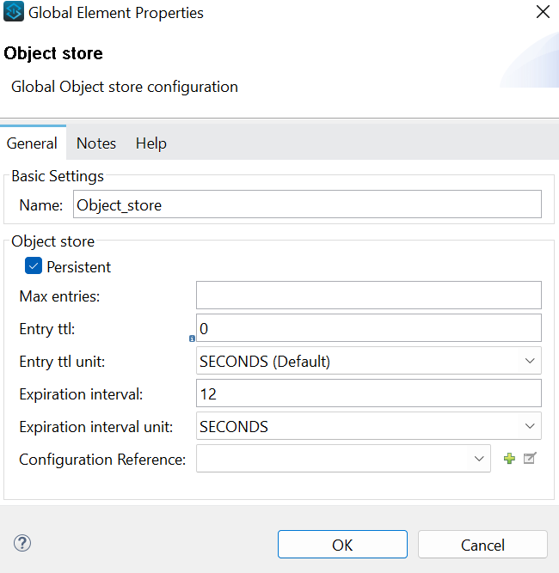

Case3 :-

Maxentries:-2

Entry TTl :- 0

Expiration Interval :- 12s

In this case key was not going to expire and if more than 2 values present in the memory after 12 sec. it will delete old key

Case4 :-

Maxentries:-2

Entry TTl :- 30s

Expiration Interval :- 5s

In this case for every 5s Expiration Interval thread was run and check the any Entry TTL was Expired and if there were any entries more than 2 it will delete the old record

If old key there is no Entry TTL expirealso it going the delete when new key was present

**Object Store V2**

Cloud Hub applications store data and access mule runtime workers within single application ,

Can be access via object Store connector or object Store Rest Api,

OnPrem Mule Application can access only via object Store Rest Api

Rolling TTL:-

* Absent TTL( entryTTL) value -4.2.1 and later rolling TTL-access data of last 7days of 30days window extend TTL to for another 30days ,retrieve ,retrieve all, retrieve all keys and store extend TTL, contains ,clear ,remove not extend TTL
* Minimum - 30 days
* Maximum – unlimited if you continue to access the data in the last seven days of the 30-days Window.

Static TTL:-

* Absent TTL(entry TTL) Value -Earlier 4.2.1- static TTL -30 days , updating data (save) rest to 30 days.
* Minimum -1 second.
* Maximum -30 days

Object Store V2(OSV2) and Subscription

* Unlimited number of entries
* For Object Store V2, The Max entries filed is not configurable.
* Store value up to 10MB
* Used as default persistent Object Store
* The value for the Key display as [binary Value] BINARY

Local object Store location:-

E:\soft\MuleSoft\AnypointStudio\plugins\org.mule.tooling.server.4.4.0.ee_7.11.0.202308241249\mule\.mule\mule-poc\objectstore